**JavaScript Memory Organization**

**JavaScript is single threaded asynchronous language - use callbacks and Promises**

**Memory organization in JavaScript**

1. 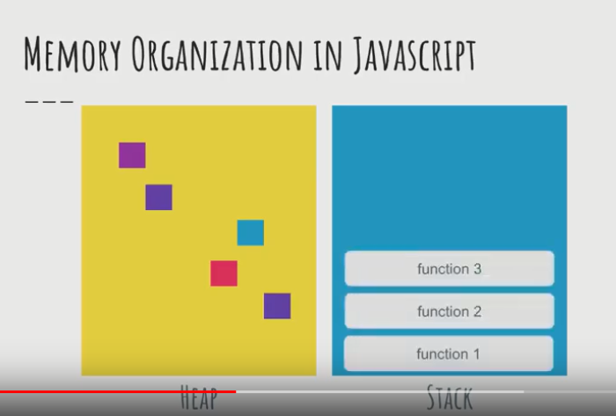
2. 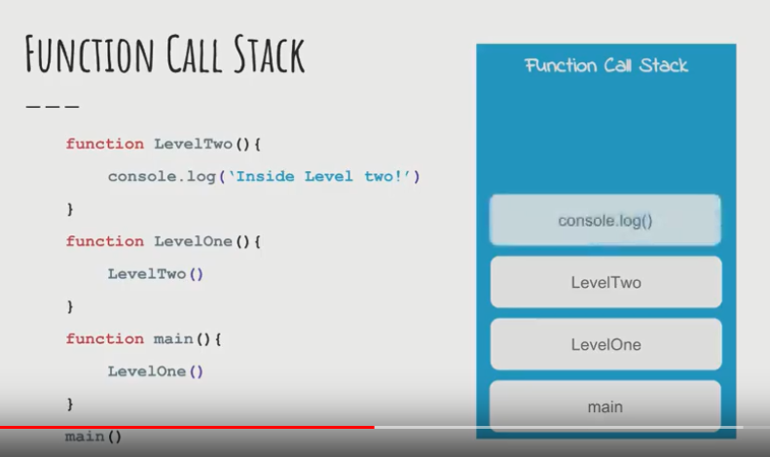
3. JavaScript is single threaded, browser on the other hand is multi-threaded to perform various tasks.
4. 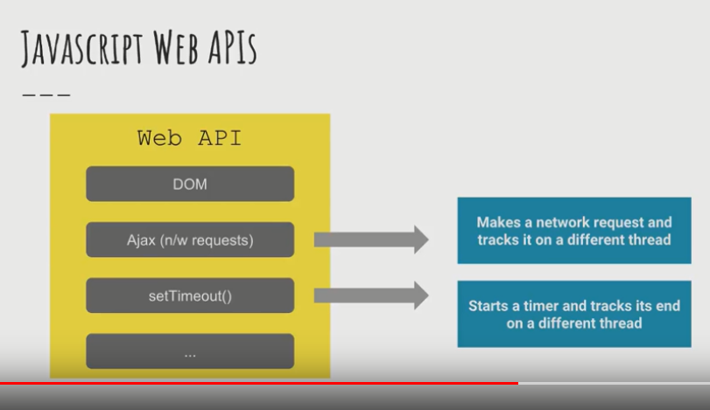
5. 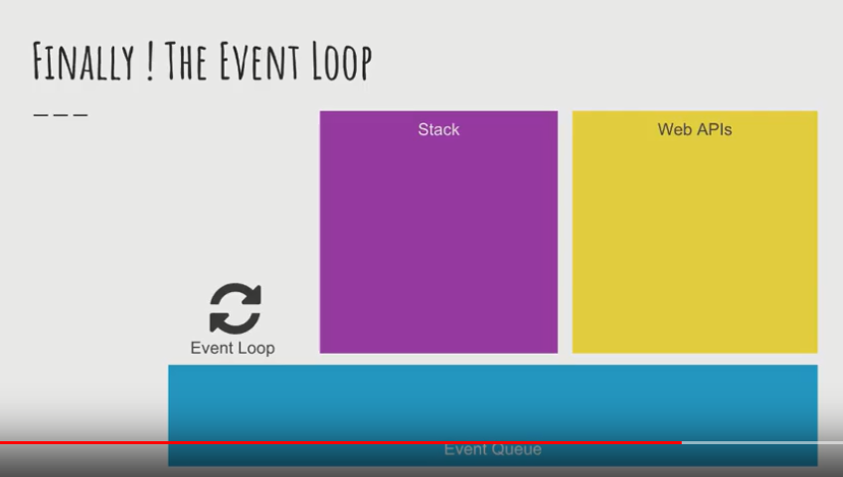
6. 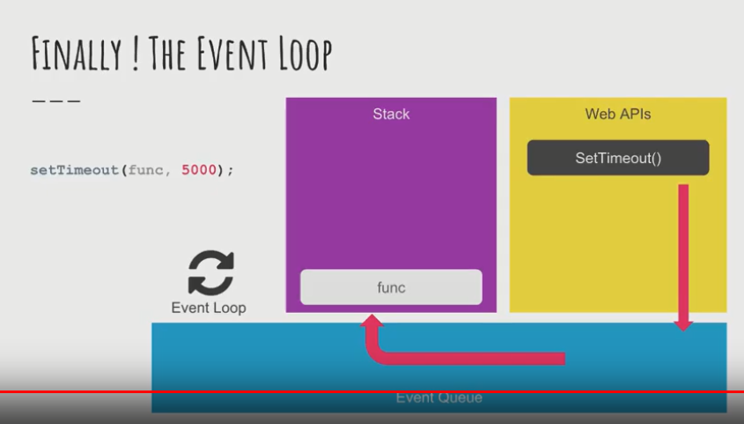
7. JavaScript gives us the illusion of being multi-threaded
8. Is Javascript synchronous or asynchronous
9. 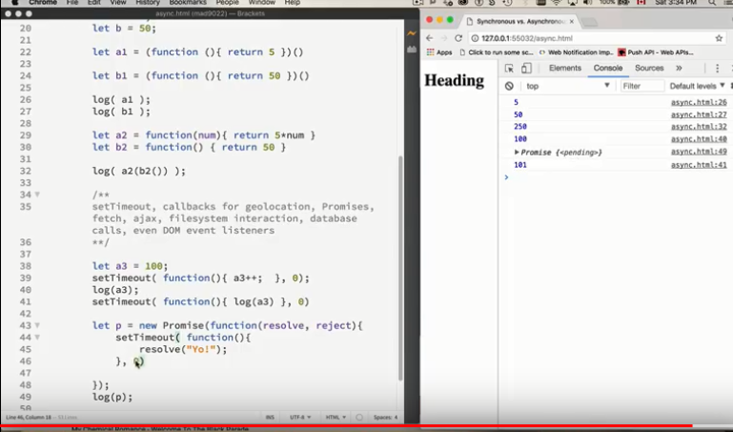
10. 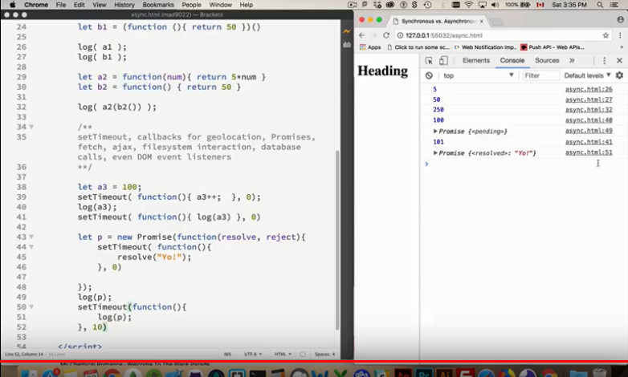
11. Service Workers in Javascript can act multithreaded
12. 
13. Webworkers work in the background in the browser; page and webworkers communicate using postmessage(); funcition
14. 
15. Messages can used using onmessage(); callback function
16. 
17. Web workers can perform calculations ins the background
18. 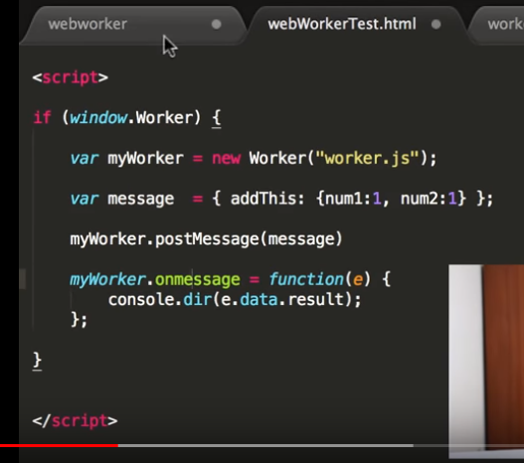
19. 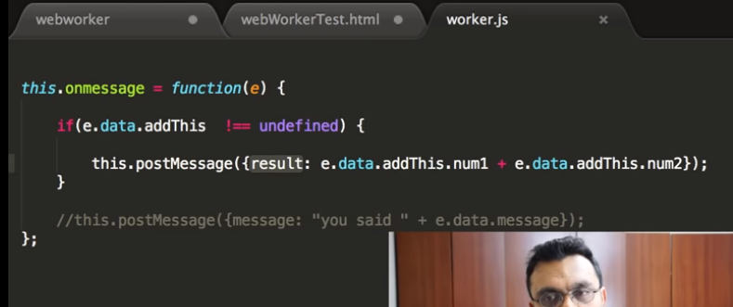
20. 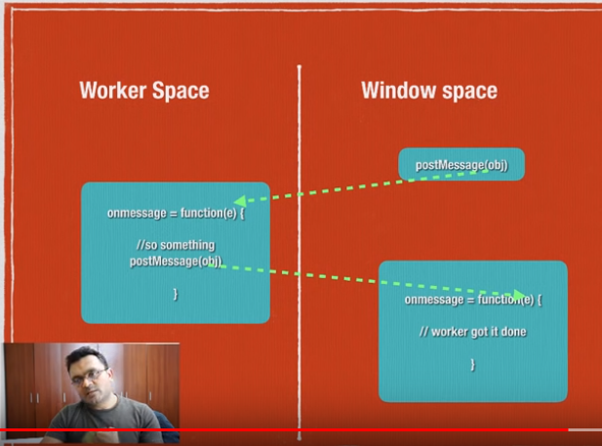
21. 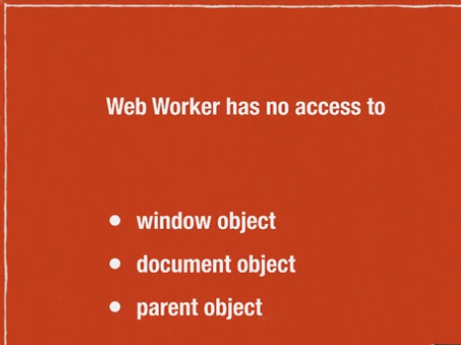
22. 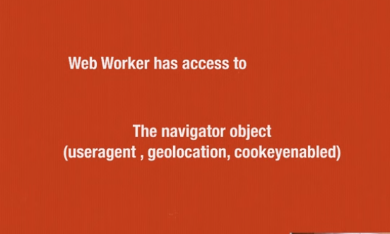
23. 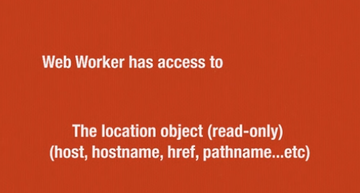
24. 
25. 
26. 
27. 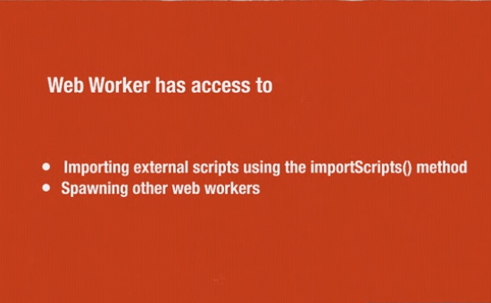
28. We can terminate the worker using
29. 
30. Importing other scripts and spawning other workers?